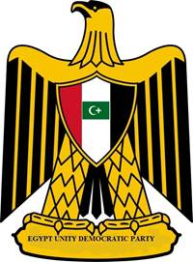 | Egypt Unity Democratic Party Newsletter  Party of Unity  http://egyptunitydemocraticparty.weebly.com/index.html
July 03, 2013 | Volume 1, Number 2
Contact Us  Maher Khalil  Chairman  Egypt Unity Democratic Party  EgyptUnityParty@aol.com | Egypt Unity Democratic Party Supports Army chief General Abdel Fattah al-Sisi for Transition President  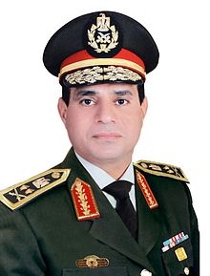  Army chief General Abdel Fattah al-Sisi  Egypt Unity Democratic Party Supports Army chief General Abdel Fattah al-Sisi for Transition President till a new election is held for a new president and parliament.  OUR STRESSES  - Abolish the current Constitution and revise a new Constitution which includes all Egyptians.  - Include Copts, Shia and other minorities in the new cabinet.  - Include all political parties in democratic process and appointments.  - Prosecute extremists from dividing the country of their speech of hate against religious minority.  - Built the Egyptian economy and healthcare system.  - Peace solution for President Mohamed Morsi’s exit.  May God Bless the Egyptian Revolution, It’s Great people

