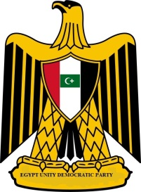 | 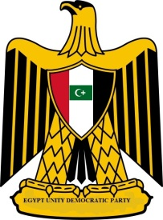  Egypt Unity Democratic Party Newsletter  Party of Unity  http://egyptunitydemocraticparty.weebly.com/index.html
January 29, 2012 | Volume 1, Number 2
Contact Us  Maher Khalil  Chairman  EgyptUnityParty@aol.com | Egypt Unity Democratic Party in Solidarity with Libyan Democratic Party  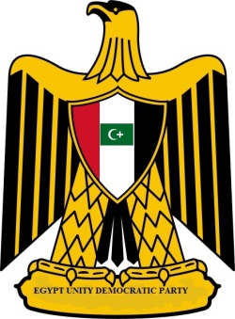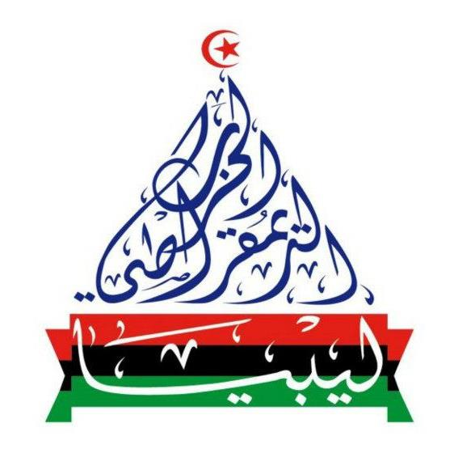  Egypt Unity Democratic supports and in solidarity with the Libyan Democratic Party for a several reasons:  - The aim of all political association is the preservation of the natural rights of man. These rights are liberty, property, security, and resistance to oppression.  - The Democratic Party will apply for membership to The Cooperation Council for the Arab state of the Gulf.  - The Democratic Party rejects the idea that the state determines the religious life of the individual, for that would conflict with the individual determining his relationship with God (religion). Religion and coercion do not meet. Man cannot serve two masters. Indeed it is a right of the individual to be able to pursue his spiritual advancement unmolested.  - The free communication of ideas and opinions is one of the most precious of the rights of man. Every citizen may, accordingly, speak, write, and print with freedom, but shall be responsible for such abuses of this freedom as shall be defined by law.  - No one shall be disquieted on account of his opinions, including his religious views, provided their manifestation does not disturb the public order established by law.  - No person shall be accused, arrested, or imprisoned except in the cases and according to the forms prescribed by law. Any one soliciting, transmitting, executing, or causing to be executed, any arbitrary order, shall be punished. But any citizen summoned or arrested in virtue of the law shall submit without delay, as resistance constitutes an offense.  These and many fundamental ideology we share with Libyan Democratic Party, including our borders with Libya and our culture.  Egypt Unity Democratic Party encourages all Libyans to rally behind Libya’s Democratic Party forever lasting peace and justice for Libya and the Arab World.  We admire the founder Ahmed Shebani’s ideology and wishes the Party many success in the following weeks, month and many years to come.

